Chapter 9, Problem 55.

Find Z in the network of Fig. 9.62, given that V_{o} = 4∠0° V

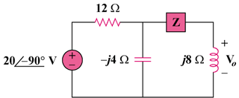

Figure 9.62
For Prob. 9.55.

